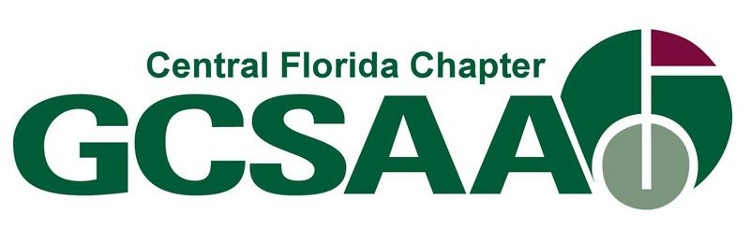

2888 Southern Dunes Boulevard,
Haines City, FL 33844
RYDER CUP MATCHES
RIDGE CHAPTER VERSUS CENTRAL FLORIDA
TUESDAY, August 11, 2026

8:00 Registration
8:30 Shotgun start
12:00 Lunch and prizes
**Shane Rice is inviting anyone to see the new irrigation installation after lunch. There will be a Q&A with the installer, manufacturer and designer.
Cost $80 for members and $100 for non-members
Format 2 man scramble – Ridge versus Central Florida
Awards First place - $100 per player
Second place - $75 per player
CTP - Gift
Please register online at CFGCSA.com or
prearranged with Dustin or Lisa. Any questions, please e-mail Lisa at lmcdowell@reunionresort.com or call me at 407-234-2374

